CS151 – Lab 6
Coqui Frog Explosion
While greatly beloved in their native Puerto Rico, Coqui frogs are considered a menace in Hawaii where they have no native predators and their high pitched 100 decibel call disturbs the tranquil tropical nights. In the absence of natural predators, the coqui frog population will grow in a manner similar to the sequence given by the Fibonacci numbers.

In this lab, you will model the population growth of the Coqui frogs using a recursive version of a function to calculate the Fibonacci numbers.

Part 1 – Implement the Recursive Version of the Fibonacci Function
In this part of the lab, you will implement a recursive version of a function to calculate a given Fibonacci number if you are given the population of the first two generations. Remember to include both a base case and a recursive case in your function design.
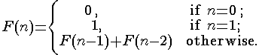

Part 2 – Another Way to Go About Things
Now, implement the following versions of the calculation:

Version 1 – Implement an Iterative Version of the Fibonacci Function
Implement an iterative version of the function to calculate a given Fibonacci number.

Version 2 – Implement a Direct Calculation for the Fibonacci Function
Binet’s Formula allows you to calculate the nth number of the Fibonacci Sequence directly.

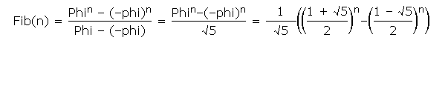
Implement Binet’s function in your program. Be careful with parentheses.

Part 3 – Questions
Answer the following questions.
- What will be the population of Coqui Frogs after 20 generations assuming that the first generation has a population of 1 and the second generation has a population of 1?

It should be 1, with no additional frogs to mate with the frog will be forever alone.

- Add a breakpoint in the recursive version of your program. Count the number of breaks for each of the following values of n and fill in the following table.
Number of Generations | Number of Calls to the Stack
3 | 2
4 | 3
5 | 7
6 | 12
7 | 20
8 | 33

- Different algorithms or approaches for solving a problem have tradeoffs. Fill in the following table to compare two approaches to this problem.

Algorithm Name | Correct | Easy to Understand | Elegance | Efficiency
Recursive | Yes | Yes | Yes | No
Iterative | Yes | Yes | No | Yes

Are there different situations where you would prefer one algorithm over the other?

I'd prefer iterative for smaller numbers, and recursive for larger numbers. Although in execution I know that iterative is more efficient so it's probably better suited for larger numbers.

- Take any two Fibonacci numbers in the sequence (for n > 6) and divide the larger of the two by the smaller. Repeat this for two other numbers in the sequence. What is the result? What is the name for this number?

Phi

Bonus (1 Point): What role did the number that you calculated in question 4 play in the development of Islamic art and architecture?

It's used as a ratio is art and for building, it's also found in nature on things like the nautilus' shell and it's used in penrose tilings. Phi can also be used to create geometric art in the shape of a pentagram, which is totally metal!

Submit your code via Laulima and turn in the worksheet.

